June 2019
Equality and diversity is important for organisational health and a positive approach can be interwoven through a museum’s activities. It is good practice to produce an Equality and Diversity Statement which is displayed clearly in the museum and on recruitment materials where appropriate.

[This is a template. Adapt this document to correspond to your own guidelines, working practices and policies.]
_________________________________________________________________________

Equal Opportunities & Managing Diversity Statement

[museum name] is committed to equal opportunities and diversity.

[museum name] will work to ensure that no staff member, volunteer or service user receives less favourable treatment on any grounds such as gender, disability, sexual orientation, age, ethnic or national origin, language, religion or belief, political or other opinion or marital status.

[museum name] also recognise that potential volunteers may have criminal records. Having a criminal record is not necessarily a bar to volunteering or working with us, and [museum name] welcomes applications from ex-offenders.

[museum name] value difference and recognise the value that different backgrounds, skills, outlooks and experiences that people bring to [Insert museum name]

[museum name] will not tolerate behaviour that contradicts the letter or spirit of this statement.

A copy of this statement will be brought to the attention of all employees and volunteers.
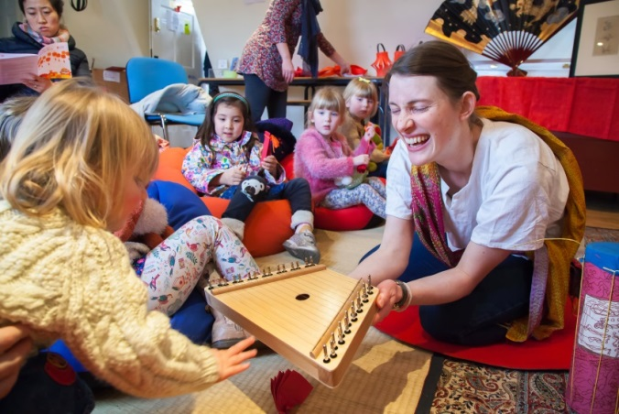

Museum of East Asian Art
© South West Museum Development, Amanda Harman Photography

