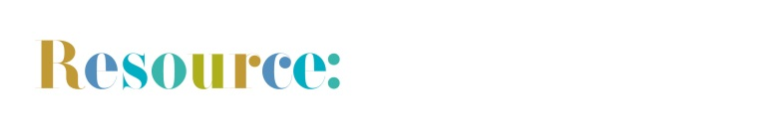
Audience Insights – Baseline Summary of Audience Data Template
Use this template to help you create a baseline summary of your previously collected audience data. You may not have relevant data for all sections, but that’s ok, just complete the sections that you can! Make sure that you clearly state how you collected your data (e.g. surveys, comments book, etc.) and once your summary report is complete, share it with your museum teams!
A baseline report is a great way to show the impact your museum has had on your audiences, demonstrate how well you have done and what can be improved – and it’s also an opportunity to say a big ‘Well Done’ to all those people who have worked hard to deliver a really great visitor experience!
NB: Text highlighted in bold is for you to delete or edit as appropriate, and you can fill in the blanks with your own data. Adapt and edit the template to make it work for you and the data that you have collected!

[Museum Name] Baseline Summary of Audience Data Report:
In 2019 we had _____ [number] of visitors to our museum.
_________ % of these were general visitors
_________ % of these were event visitors
_________ % of these were group bookings
And ___________ % of these were school groups

We collected feedback from our general visitors though [Surveys/comment books etc].
___________ % of our visitors provided us with a response, and we asked questions about…

[List some of the questions you asked here]

In 2019 we the museum was open between [date] and [date].

[Detail a little of what you had on offer for visitors].

We also welcomed many booked groups and school visits to the museum.

________ % of respondents were [on holiday in the area] whilst
________ % were visiting area [on a daytrip].
________ % had visited the museum before
________ % said that this was their first visit to the museum
________ % said they were visiting with another [Adult(s)] and _______ % were visiting [With children/as a family]
We had visitors from all over the UK – from the [northernmost, southernmost, easternmost and westernmost location]
________ % of our respondents were from the local area (determined by a 30-minute drive-time radius of the museum) OR were from the town/county
________ % of respondents were visiting us from overseas.

Our visitors told us that they heard about the museum from…
[You can list some of the marketing channels your visitors have identified here].
Here’s what they said they enjoyed most about their visit…
[Include some good comments]
And here’s what they thought we could improve upon…
[Include some constructive comments]
We asked our visitors to tell us how old they are.
________ % of respondents were aged between [Age – Age/Aged under….]
Just _______ % of respondents were aged between [Age – Age/Aged under….]
________ % of respondents were Female
________ % of respondents were Male
________ % were other/preferred not to say

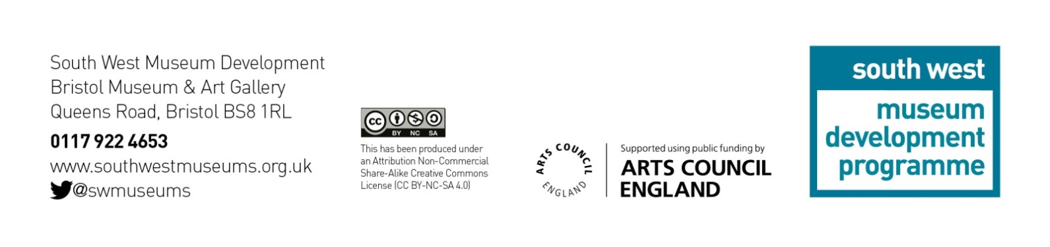
Summary of Findings
[Write a short summary of what your data findings are telling you here]

