July 2023
Template: Action Plan to Achieve/Maintain Museum Accreditation

This document is designed to help you map out a plan for achieving Museums Accreditation either as a museum new to the Accreditation scheme or as a museum accredited under the 2011 Standard, working towards submitting an Accreditation 2018 return.

This document is intended simply to be helpful. There is no requirement to use it as part of the Accreditation process if you do not wish to.

The Template takes you through all the points on the Accreditation application form. Not all points are relevant to all museums. It is therefore essential to refer to the Accreditation application form, the Accreditation Standard and the section Guidance documents as you work through this template. The standard, the guidance and application form are accessed online at
https://www.artscouncil.org.uk/supporting-arts-museums-and-libraries/uk-museum-accreditation-scheme

The action plan which you create should be a working document and items identified as action points should be included in your museum’s current forward plan, or equivalent.

For further advice and information about the Accreditation Scheme contact:

- Your Museum Development Officer
- Your Accreditation Adviser – museum.accreditation@bristol.gov.uk
- Museums without a professionally qualified member of staff should also contact their Accreditation Mentor
- The scheme is developed and administered by Arts Council England, www.artscouncil.org.uk

Further guidance documents are available at:

- www.southwestmuseums.org.uk
- https://www.artscouncil.org.uk/supporting-arts-museums-and-libraries/uk-museum-accreditation-scheme
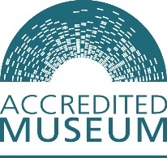
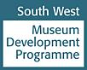
- www.collectionstrust.org.uk/
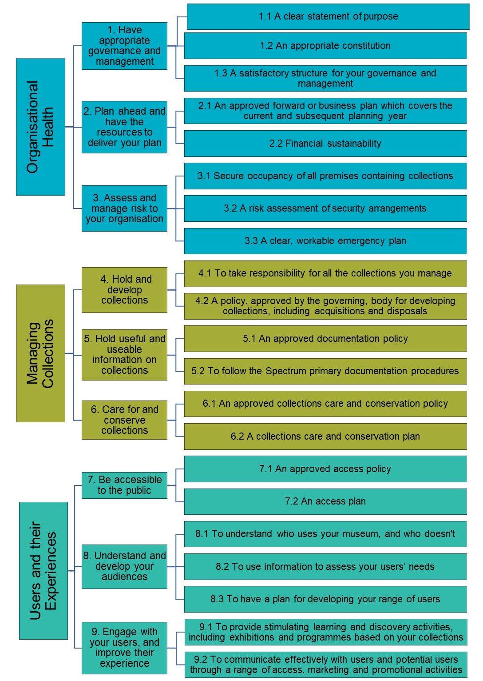

Template: Action Plan to Achieve Museum Accreditation

Organisation:
(Name of Museum)

Complied by:
(Name of individual)

Position:

Date:

Areas for Improvement to be addressed (this applies only to museums that are already Accredited)

Please copy and paste any Areas for Improvement that were identified in the award letter from your last Accreditation return. This way you can make sure that you are able to update ACE on your next

Areas for Improvement | Action taken | Completion date

Template: Accreditation 2018 – Action Plan toolkit

Organisational Health
Requirement |  | Page in Guidance | Done / Not Done | Use this column to record what you have to do, and make other notes. | Target Date for completion | Led by  ……

1. Have appropriate governance and management
1.1 | A clear statement of purpose
 | Statement of purpose exists /is still appropriate? | 21
1.2 | An appropriate constitution
 | Copy of most recent constitution available? | 23
 | Amendments to be made?
 | Does constitution give power to operate a museum and hold collections?
1.3 | A satisfactory structure for your governance and management
 | Is there an organogram or similar showing the management and workforce structure(s) available? | 26
Are you able to confirm:
- who has the authority to approve decisions, policies and plans?
- provide supporting documents for this?
 | Can you describe how the museum ensures there is appropriate professional input into decision making and policy development? Details of that experience are required
If your museum requires an Accreditation Mentor, do you have:
- a signed agreement with them?
- a minute confirming their appointment?
- A mentor report?

Can you confirm arrangements for:
- Recruitment and induction
- Identifying training needs, training and CPD
- Succession planning
(of paid and volunteer staff and the governing body)

 | Museums run by a separate organisation to the governing body: is a copy of the management agreement/contract available?

2. Plan ahead and have the resources to deliver your plan

2.1 | An approved forward or business plan which covers the current and subsequent planning year
 | Do you have a Forward/Business Plan? | 30
 | Statement of Purpose and Key Aims formally approved by the Governing Body/person with delegated authority and a signed minute procured?
 | Will your current Forward Plan still cover at least the reminder of the current planning year and the subsequent planning year on the date you submit your Accreditation return? |  |  | If the last Forward Plan you submitted to ACE is still in date, then you do not need to submit a new Forward Plan
 | Does the plan include:  - Statement of Purpose (also known as a mission statement)  - The dates the plan covers  - Key Aims you’ll want to achieve over the plan’s duration  - Details of how you’ll achieve these aims (SMART specific objectives and an action plan)  - Details of what you’ll need to achieve the aims (people, equipment and money)  - Budgets for the current and subsequent planning year  - A review date | 31

2.2 Financial sustainability
 | Can you provide certified copies of accounts for the last two financial years? (A link to published accounts is fine) | 34

3. Assess and manage risk to your organisation
3.1 | Secure occupancy of all premises containing collections
 | Are you able to describe the basis on which all premises containing collections are occupied? (owned, leased, period of rental, etc) | 36
 | If the current arrangement(s) has (have) less than 12 months to run can you evidence that you have started negotiations on renewing the lease or finding alternative premises?
3.2 | A risk assessment of security arrangements
 | Has a risk assessment of the security arrangements of your museum (collections, visitors, workforce, buildings) been undertaken in the last five years? | 38
 | Can you evidence how the recommendations of that review have been/are planned to be implemented?
3.3 | A clear workable emergency plan
 | Do you have an emergency plan that has been reviewed in the past five years? | 40
Does the plan cover:
- Arrangements for the workforce, collections and collections information?
- A risk assessment of threats?
- How the plan is authorised, maintained, tested and communicated to the workforce and the emergency services?
- An understanding of salvage priorities and information on first aid steps for objects?
- A review procedure and date?

Collections
Requirement |  | Page in Guidance | Done/ not done | Use this column to record what you have to do, and make other notes. | Target Date for completion | Led by  ……..

4. Hold and develop collections
4.1 | To take responsibility for all the collections you manage
 | Do you know:  - The size of the collections in your care?  - The proportion that are loan?  - That all loan agreements are up to date? | 43
4.2 | A policy approved by the governing body for developing collections including acquisitions and disposals
 | Do you have a collections development policy (acquisition and disposal) based on the 2014 template published by Arts Council England? | 45
 | A signed minute that confirms the approval of the policy by your governing body or the person with delegated authority?
Does the policy include:
- Your statement of purpose?
- A history of the collections?
- An overview of the current collections?
- The themes and priorities for future collecting?
- The themes and priorities for rationalisation and disposal?
- Information on the legal and ethical framework for acquisition and disposal?
- Reference to the policies of other museums where you collect in the same or related areas or subject fields?
- A review date?

5. Hold useful and useable information on collections
5.1 | An approved documentation policy
 | Does your museum have an approved documentation policy? | 51
 | Is a signed minute of approval of the policy by the governing body or person with delegated authority available?
Does the policy cover:
- Accountability?
- Standards in procedures and processes?
- Accessibility?
- Security?
5.2 | To follow the Spectrum primary documentation procedures
 | Does your museum’s documentation procedural manual include step by step instructions for completing the 9 Spectrum primary procedures at your museum?  - Object entry  - Acquisition and accessioning  - Location and movement control  - Inventory  - Cataloguing  - Object exit  - Loans in  - Loans out  - Documentation planning | 53
 | Are all 9 primary procedures being implemented?
Have you completed the inventory standard (4)?
If not is a plan in place for completing it? (You may be asked to submit it)

6. Care for and conserve collections
6.1 | An approved collections care and conservation policy
 | Do you have a policy that guides preventative and remedial conservation in your museum? | 55
 | Do you have signed confirmation that the policy has been approved by the Governing Body or person with delegated authority?
Does the policy cover:
- The standards you use to look after your collections?
- How you receive expert guidance on collections care?
- The care of specialist collections (if any)?
- How you communicate the policy to the workforce and contractors
- A review date
6.2 | A Collections care and conservation plan
 | Do you have a plan for maintaining and improving the care of your collections? | 57
 | Does the plan include (as a minimum):  - Information on housekeeping practice?  - Information on environmental monitoring in your galleries and stores?  - Information on object handling, packing and movement?  - Information on buildings maintenance?  - Arrangements on pest monitoring and control?  - Information on threat identification and management? | 58

Users and their experiences
Requirement |  | Page in Guidance | Done / Not Done | Use this column to record what you have to do, and make other notes. | Target Date for completion | Led by  ………

7. Be accessible to the public
7.1 | An approved access policy
 | Does your museum have an access policy informed by an access assessment? | 61
 | Do you have signed confirmation that the policy has been approved by the Governing Body or person with delegated authority?
Does the policy include information on:
- How you identify the access needs of users?
- Information about the range of interpretation methods you use?
- Information on how you enable public access to your museum, collections and information?
- Use of languages other than English (if applicable)?
- How you balance the needs of the collections with those of access?
- A date for review?
7.2 | An access plan
 | Does your museum have a plan to improve the physical, sensory and intellectual access to your collections and buildings? | 63
 | Does the plan outline priorities for action based on your access policy and access assessment?  The access assessment can include:  - An access audit  - Work with focus groups, advocacy groups, charities, experts  - A facilities checklist  - A review of interpretation and collections use | 63, 64

8. Understand and develop your audiences
8.1 | To understand who uses your museum and who doesn’t
 | Can you describe:  - Who your museum’s current users and non-users are?  - How you collect information about your users and non-users?  - The plans you have for improving your provision for existing users and for under-represented groups? | 67
8.2 | To use information to assess your users’ needs
 | Can you describe:  - How you analyse and respond to users’ comments?  - How you take those comments on board when planning improvements?  - How this activity is evidenced in your Forward/Business Plan? | 69
8.3 | To have a plan for developing your range of users
 | Do you have a plan to broaden your range of users, based on the evidence gathered through consultation? | 71
 | Is that plan part of your Forward/Business plan or a separate, stand-alone document?

9. Engage with users and improve their experience
9.1 | To provide stimulating learning and discovery activities, including exhibitions and programmes based on your collections
 | Can you describe what learning experiences are available at your museum? These may include:  - Exhibitions  - Talks / walks/talks  - Publications  - Formal schools service  - Activities in the museum and online | 73
9.2 | To communicate effectively with users and potential users through a range of access, marketing and promotional activities
Can you describe how you make information available to users and potential users? This may be through:
- Printed media
- Online activity (website, social media, Culture 24)

