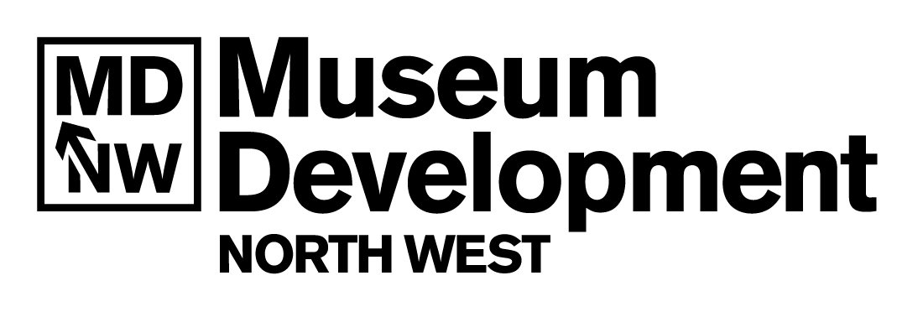

Museum Development North West Privacy Policy

In line with the Data Protection Act 1998 and the UK General Data Protection Regulations 2021, Museum Development North West takes your privacy seriously and will ensure that your personal data is safe and kept confidential.

This Privacy Policy outlines how and why we use your personal information; the terms of this statement may change, so please check it from time to time.

Background
Museum Development North West (MDNW) is funded by Arts Council England (ACE) and managed by the University of Manchester. It provides support and advice to Accredited museums in the North West through:
- Training opportunities
- Grants
- Events
- Networking opportunities
- Dissemination of advice and information from third party sector partners

In order to fulfil this role MDNW holds personal data (including email address, contact details and access requirements) to promote and carry out our programme of activity. This is currently mainly via electronic means through the MDNW blog on Wordpress, Eventbrite, SurveyMonkey, Twitter and Zoom.

What do we use the information for?
If you have given us permission to email you by signing up to our blog, we use this information to send you copies of blog posts from our website, direct to your email inbox. We make sure details are up to date and accurate. If you ever wish to unsubscribe from our blog, our mailings have an unsubscribe link included.

We use information from our blog and Twitter to generate anonymous reports on the usage of our website and social media interactions which may inform our funding reports.

If you have signed up to a workshop through our Eventbrite page, we use the information supplied by you to organise and run the event, including logistics and access requirements when required, and giving you secure admission into our online workshops run via Zoom.

The lawful basis that we use for processing the data is that either:
- You have given us your consent
Or
- The processing is necessary for the purposes of legitimate interests pursued by the Data Controller (MDNW). In this case the legitimate interest is to carry out the objectives of the organisation

Who will we share your personal data with?
We will not pass on or sell your information to a third party for their marketing purposes. Any information we disclose about you, other than for purposes as mentioned within this policy, will be when required to do so by law.

As part of our contract with ACE we may share information regarding the MDNW programme with representatives from ACE. This may include names of participants at events, grant applicants and contact names for Accreditation purposes.

Specific elements of the MDNW programme require us to share personal information with third parties such as trainers, consultants and other sector organisations who directly support the programme. In these circumstances when you apply for a place on a workshop or development programme we will ask your permission to pass on your personal details to the third party. They only use your data for our specified purpose and will not use it for any other reason or share it with any other organisations. The information we ask for when you book a place on one of our workshops has been agreed with and is consistent across all Museum Development providers in England, and asks only for the information necessary for us to deliver our programme.

In the course of our work we use third party websites (Wordpress, Eventbrite, Twitter, Dropbox, SurveyMonkey, Youtube, Zoom) and have taken into account the data protection policies of these companies.

Your rights
It is important to us that you receive the maximum benefit from the MDNW programme and are able to participate in all aspects knowing that we are treating your personal data in an appropriate, safe and confidential manner.

The Data Protection Act 1998 and the UK General Data Protection Regulations 2021 give you certain rights and you can read these in full at https://ico.org.uk/for-organisations/guide-to-the-general-data-protection-regulation-gdpr/. We are managed by the University of Manchester and the University’s Privacy Policy is here - http://www.manchester.ac.uk/privacy/.

You are entitled to see information we hold on you. This is called a Subject Access Request. You need to put your request in writing. You will also need to prove to us your identity, by supplying original or notarised ID. It is important that you prove your identity before we can send you any details. If you require this information please email Lynsey Jones, Museum Development Officer, lynsey.jones@manchester.ac.uk.
You can also:
- Withdraw your consent by asking us to stop emailing you
- Ask us to update our records
- Ask us to consider a request from you to stop processing your data
- Complain or discuss the way that we are handling your information

For any of these requests please email Alex Bird, Museum Development Officer, alexander.bird@manchester.ac.uk.

You can also seek further advice from the Information Commissioners Office, details are at https://ico.org.uk.

Museum Development North West, April 2018
Revised October 2020
Revised February 2021

