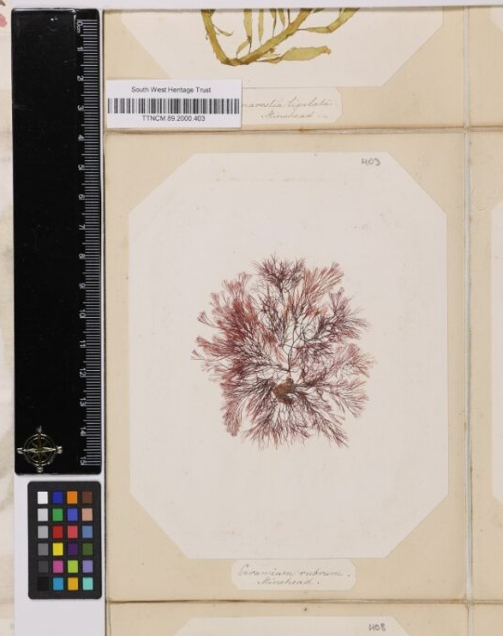
Image © South West Heritage Trust
South West Area Natural Sciences:
Setting Natural Science Collection Data Free
Public Report
Authors:
Roz Bonnet, South West Museum Development
Isla Gladstone, Bristol Museum & Art Gallery
Contributors:
Helena Jaeschke, South West Museum Development

V1. 2023
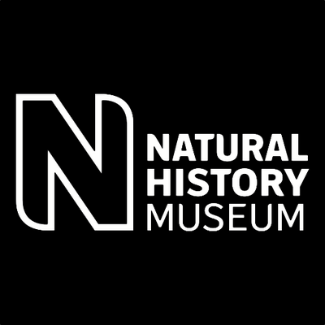
Introduction
South West Area Natural Sciences: Setting Natural Science Collections Data Free was a collaborative pilot project aiming to help inform how the needs of regional institutions can be accounted for in an emerging national infrastructure called DiSSCo UK, the Distributed System of Scientific Collections.
DiSSCo UK seeks to empower institutions across the UK to digitise and share their natural science collections, bringing their unique evidence about the natural world together in a distributed digital and physical infrastructure. The UK houses some of the world’s most important natural science collections, but the vast majority are not discoverable digitally. Unlocking their combined potential through digitisation can support research, innovation and engagement in urgent areas such as climate change, biodiversity loss, human health, and sustainable futures.
The pilot took place between April and July 2023, and was delivered by a collaboration between:
- South West Museum Development (SWMD) - the Arts Council England funded Sector Support Organisation providing trusted, local, and relevant development services for approximately 220 museums in the ONS south west region of England. Hosted by Bristol City Council, Culture & Creative Industries service, it is part of a UK-wide network of Museum Development Providers.
- Bristol Museum & Art Gallery (BMAG) - part of Bristol City Council’s Culture & Creative Industries service, BMAG is a recognised regional hub of expertise and leadership in natural science collections and their relevance to the climate and ecological emergencies. BMAG delivers research and engagement drawing on biodiversity data from Bristol’s collections at a local level in collaboration with Bristol’s Regional Environmental Centre, also hosted by C&CI.
- Natural History Museum London (NHM) - the UK national leading DiSSCo UK and a major national centre of taxonomic and technical digitisation expertise.
In this collaboration, SWMD provided regional intelligence to identify three south west organisations of varying typology to take part in pilot digitisation, and museum development support to enable their participation. BMAG provided regional natural science collection expertise and acted as a ‘translator’ for national-level work. NHM brought technical digitisation expertise, knowledge of international infrastructures, and national-level advocacy.
This project was part of a bigger scoping-project led by the NHM ‘Setting natural science data free: scoping a UK collections approach’, funded by the Arts and Humanities Research Council (AHRC).
Pilot background
The pilot drew on previous work led by BMAG and SWMD in 2015-17 which had connected with over 30 south west organisations to explore regional natural science collections, skills and networks - the South West Area Natural Sciences Collections Project, funded by the John Ellerman Foundation.
It also built on foundation work in 2022, where NHM administered Arts and Humanities Research Council funding for SWMD to purchase natural science collection digitisation equipment for use by regional organisations, upskilled SWMD and BMAG staff on the digitisation process to develop a train the trainer approach, and worked with the partners to refine the pilot.
The Pilot
The pilot explored digitisation in three museum/heritage organisations of different typology (size, governance, and workforce characteristics) to help inform how these factors affect digitisation projects:
- Bristol Museum and Art Gallery (Bristol Culture and Creative Industries)
- Museum of Somerset (South West Heritage Trust)
- Newton Abbot Museum
Participant organisations were asked to digitise a minimum of 100 pinned insect specimens or 50 herbarium sheets to test existing DiSSCo UK workflows, using digitisation equipment loaned by SWMD.
The pilot specifically sought to understand the capacity, expertise and resources required during pilot digitisation, aiming to:
- build understanding of digitisation processes, workflows and platforms
- support development of guidance tailored to wider sector participation
It also examined through a self-led organisation and workforce assessment devised by SWMD and a facilitated collections self-assessment audit supplied by NHM:
- how museum operations impact participation
- the factors or barriers for success
Finally, the pilot also looked at how museums can engage audiences in the value of natural science collections.

Case study: Bristol Museum and Art Gallery
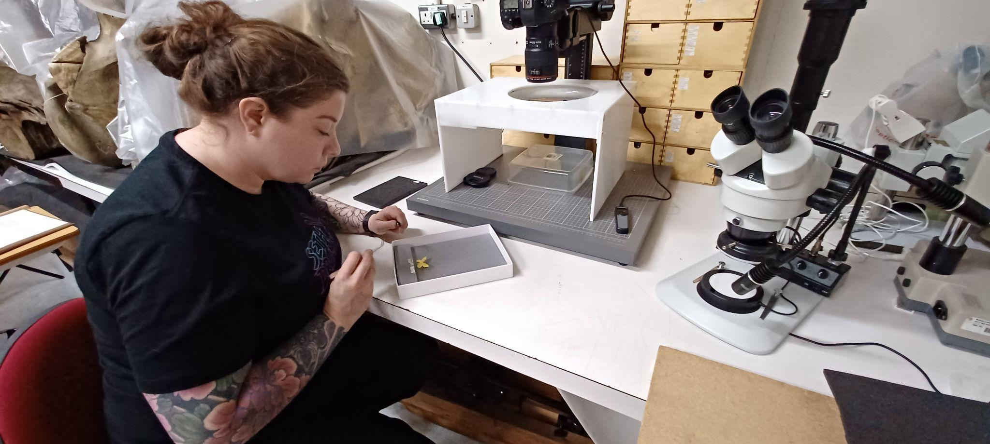
Image © Bristol Museum and Art Gallery
Profile
A large local authority museum, under Bristol City Council (BCC), located within the city of Bristol, part of a multi-site service of five museum sites. The museum has a paid workforce and is supported by volunteers. There are dedicated natural sciences curatorial staff, including the current Co-Chair of NatSCA Natural Sciences Collections Association Subject Specialist Network (SSN). The museum has by far the largest collection of natural science specimens in the south west at an estimated 1.35 million specimens, with its geological collection holding Designated Collection status.
Specimens digitised
The museum digitised 195 pinned insects (butterflies and moths) from the Douglas Gordon Gibb collection of British Lepidoptera primarily collected from Avon, Somerset, and Gloucestershire between 1932 and 1969. Gibb worked for the BBC and was a member of the Bristol Naturalists’ Society. The collection of 8,000 specimens was already being digitised to support museum projects as it is rich in data from the Bristol region. It was incorporated into the pilot so staff could directly compare previous and new workflows (such as the incorporation of barcoding) and explore the impact of improved workflows for museum users.
Successes, impacts and challenges
The museum reported several successes from their participation. These included increased staff knowledge and skills, and upgrades to the organisation’s natural science collections digitisation practice - such as use of multi-field barcoding which has automated image renaming and data transcription therefore removing backlogs previously reliant on curatorial time to process. This has brought immediate impacts for users of the collection and for understanding of local biodiversity - through quicker release of more accurate and reliable specimen data to three museum projects currently drawing on this:
- Students from the University of the West of England surveying butterfly and moth diversity and abundance in the areas Gibb previously collected to understand changes in population.
- Adding data to a creative citizen science interactive being developed for audience engagement with local wildlife histories and nature recording in BMAG’s British Wildlife Gallery.
- Extracting data as part of the West of England Combined Authority funded Pollinators project, co-ordinated by the Bristol Natural History Consortium.
Working collaboratively with national and regional organisations has contributed to BMAG’s leadership in supporting climate and ecological research and engagement. In turn this work will benefit understanding of Bristol’s wildlife through connection with region-level ecosystem data and the national biodiversity picture, as well as increased research access to local data, and innovations in collection use.
The museum reported the following key barrier which directly affected their participation in the pilot: the length of time to procure software in compliance with internal processes. This caused delays to the museum’s ability to begin digitisation within their preferred time frame.

Case study: Museum of Somerset (South West Heritage Trust)
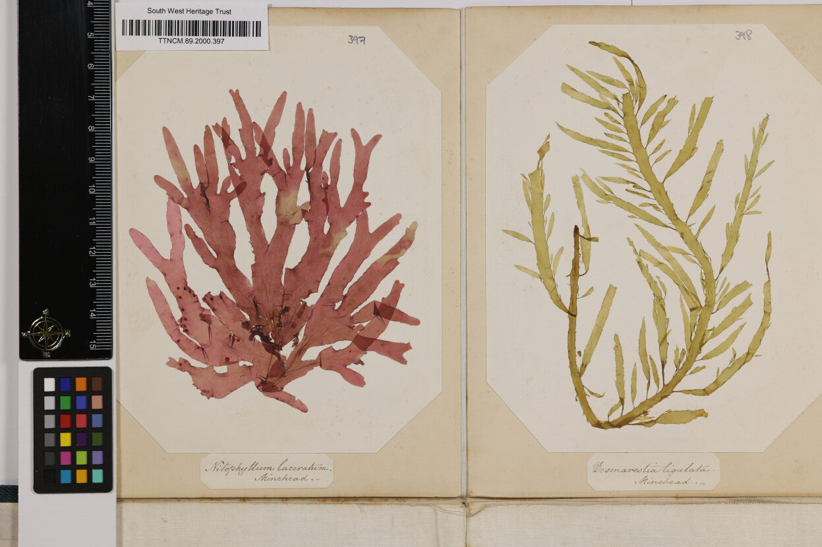
Image © South West Heritage Trust
Profile
An independent heritage organisation managed by a charitable trust, located within Taunton in Somerset, part of a multi-site service with three museum sites. The museum has a paid workforce including two curatorial staff across collections and is supported by volunteers. There are approximately 117,600 natural science specimens in its collections.
Specimens digitised
The museum digitised 119 pressed seaweed specimens collected from Somerset, part of a wider collection of 953 specimens collected by Isabella Gifford in the 1840s, 1850s and 1860s. The museum aimed to link an online output from this pilot project via a QR code with a small display on Isabella Gifford planned for August 2023. Additionally, the images generated through the pilot project would provide publicity material for the new display, as the specimens are not only scientifically important, but visually engaging and have previously been of interest to artists and researchers investigating Victorian women seaweed collectors.

Successes, impacts and challenges
The museum reported several impacts as a direct result of their participation in the pilot. These were primarily focussed on the ability to connect with natural science specialists within the region and nationally, supporting awareness of natural science sector standards, strategic development opportunities including mechanisms for engaging audiences with these collections, and the advantages of automating time-consuming documentation and digitisation tasks through technology such as uploading of images and data to the collections database.
Technical challenges included use of the digitisation workflow which is designed for batch-processing homogenous collections, rather than specimens which vary in size and shape resulting in the need to crop images for which the software did not have appropriate functionality, and the requirement to attach barcodes to specimens - as the collection has high aesthetic, historic and social value, barcodes were not directly attached.
Further in-depth training and resources would be welcome to support the level of specialist knowledge and experience required for working with natural science collections, as well as longer lead times and clear expectations of participation to support staff capacity to engage.
The Gifford seaweed collection is now on temporary display at The Museum of Somerset: Isabella Gifford Seaweed Collection – South West Heritage Trust (swheritage.org.uk).

Case study: Newton Abbot Museum
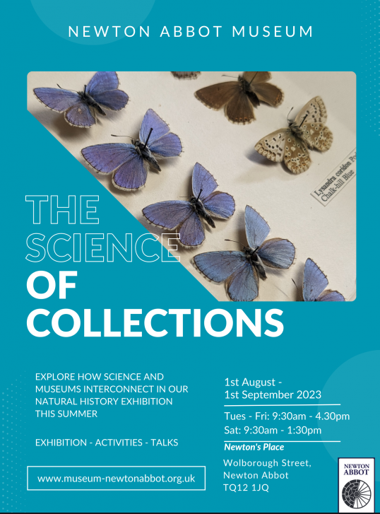
Image © Newton Abbot Museum
Profile
A small single-site local authority museum located within Newton Abbot in Devon, operated by Teignbridge District Council. The small museum workforce includes curatorial staff but no natural science subject specialist and is supported by many volunteers. The museum has approximately 3,000 natural science specimens within its collection, which are currently used for display and research.

Specimens digitised
449 specimens were digitised from the Mapleton Collection, collected by Henry Mapleton, a local Newton Abbot doctor who collected butterflies in his spare time. The collection consists of two cabinets containing 50 drawers of moth, butterfly, caterpillar, and beetle specimens collected and collated between 1890 and 1932.
As with many historic collections, the collection has been damaged by pest infestation. The museum received prior support from SWMD’s Conservation Development Officer and the Curator of Biology at BMAG to stabilise the collection, identify the specimens and record specimen information ahead of participation in the pilot, as part of a SWMD grant.
Successes, impacts and challenges
Specimen data was made accessible, the fragile collection stabilised and high-quality images produced for future use. Connecting with regional natural science specialists supported understanding of the collection, and an exhibition ‘The Science of Collections’ was delivered 01 August to 01 September 2023. The profile of the museum and its collections was raised as digitisation efforts caught the attention of the media, featuring on BBC Spotlight (regional television news programme) and in a news article, raising awareness of the potential of natural science specimens for environmental research. The project also caught the imagination of the local community and a significant number of new volunteers, especially younger people, who were attracted to join the digitisation team.
The museum reported challenges in the level of new skills required to utilise the new techniques in the pilot, though prior support from SWMD and BMAG staff and the loan of equipment ideal to their chosen collection type supported their engagement. A further challenge was availability of space for digitisation.

Pilot Recommendations
DiSSCo UK offers rich opportunities to release the potential of regional UK natural science collections to support research and engagement in urgent challenges high on local and national agendas, including the climate and ecological emergencies. The following recommendations are made for consideration in the development of this infrastructure, to enable regional organisations to participate:
- Two-way regional-national benefits are actively integrated into the national infrastructure to support its sustainability. DiSSCo UK amplifies and interlinks with regional work, and is careful not to extract from stretched regional institutions. This may be achieved by linking the benefits of digitisation to locally-relevant scenarios that resonate with local funders, stakeholders, communities and users. For example, supporting place-based narratives, or alignment with key funders such as Arts Council England, National Lottery Heritage fund or local authorities, whose priorities include environmental sustainability and widening participation.
- Understanding of varied regional ecologies continues to be developed. Factors such as regional infrastructures and expertise, resource pressures, collection governance types, local priorities and agendas, are explored through visits, workshops or pilots based in the regions, as well as community online meetings.
- DiSSCo UK invests and aligns with existing regional support infrastructures such as Museum Development. This can help ensure greater regional buy-in and relevance, in turn providing wider research accessibility and national reach. The Museum Development infrastructure provides a cost-effective way of developing and supporting partnerships and projects.
- Regional museum professionals are supported and championed, to help ensure valuable expertise is retained within the regions. Regional institutions currently face significant resource pressures, including reductions in natural science subject specialists and simultaneous balance of multiple funders and stakeholders. Local staff are essential to sustaining a research infrastructure, through unique local collections knowledge, curation/management/engagement, and hosting and facilitation of project teams. Support for staff may include access to national expertise and training, such as taxonomic or digitisation; development of ‘super-users’ to sustain regional expertise; a national platform to amplify impacts of regional colleagues’ work.
- Senior leadership engagement and partnership frameworks are developed: Senior leaders, including those who are not natural science subject specialists, are provided with bespoke opportunities to learn more about the project ambitions, and help articulate its local and regional benefits. There are clear expectations to support effective recruitment of participant institutions which are formalised through partnership agreements benefiting both parties and to underpin effective working arrangements.
- Resources including funding and equipment are provided to release capacity of local staff to engage in digitisation. Recognising input required from existing staff as well as project teams.
- Regionally-tailored resources are developed to support effective digitisation: Current DiSSCo UK training resources are augmented to reflect the multiple roles individual regional staff often undertake, and support engagement of non-subject specialists. Based on learning from this pilot, these include:
  - A technical glossary of key words and terminology, with clear worked examples, to promote consistency and avoid different interpretations.
  - Resources supporting skills required before or after digitisation, such as handling or condition assessment of specimens in the pre-curation stage.
  - Consideration of options such as citizen science for resource or expertise-heavy stages such as transcription or georeferencing.
  - Support for automated ingestion of digitisation outputs (images and data) to the organisation’s own Collections Management System, to avoid manual backlogs.
  - Access to live problem solving for unanticipated questions;
- Information pertaining to rights management and potential for commercial exploitation of an organisation’s data is made clear at the outset: Participant institutions must clearly understand use of the data, images and accompanying information made accessible as part of digitisation efforts. Potential ramifications must also be understood. This includes the potential commercial exploitation of their data, as participant organisations are unlikely to have specialist expertise in this area in-house to support informed decision making.
- Digitisation of global collections is navigated in collaboration with local and source communities, and experts beyond the natural sciences community: Whilst this pilot focused on digitisation of natural heritage collected locally to the holding organisation, many UK institutions care for material collected globally including in colonial contexts. The processes and benefits of digitising these collections must be considered to enable fair and equitable sharing, and local needs. Suggested approaches are explored by Kaiser et al 2023.

Appendix 1
Entomology digitisation workflow
This workflow is designed to support the digitisation of pinned insect (entomological) specimens in south west museums, using equipment loaned by South West Museum Development. The workflow supports digitisation of regional collections according to best practice, making them accessible by researchers. You can read more about the wider goals and benefits of this work on the website of DiSSCo UK (The Distributed System of Scientific Collections) at https://www.dissco-uk.org/
GETTING STARTED
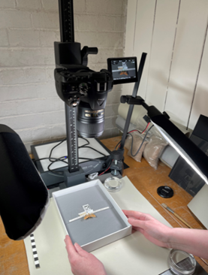
Prepare your digitisation equipment:
- Connect the 4-gang socket extension lead.
- Set up the laptop and connect it to the power source.
- Set up the Kaiser copy stand: insert the column into the baseboard column mount, engage the 2 locating pins then screw in the bolt.
- Attach the camera securely to the copy stand.
- Remove the camera lens cap.
- Connect the camera to the power source with the cable.
- Connect the camera to the laptop.
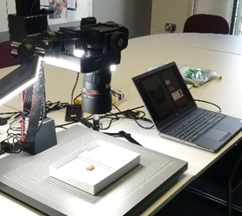
- Open Canon EOS Utility software: this should launch automatically when the camera is connected to the laptop.
- Check the ISO, shutter-speed, and aperture settings on the EOS Utility window.
- Set up the 2 LED lights to provide uniform lighting across the specimen and connect them to the power source.
- Locate the hard drive for image saving at the end of your digitisation session.
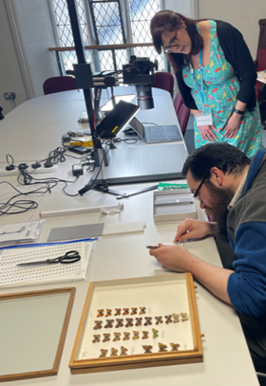
Have your tools ready:
- PPE: including well-fitting impermeable gloves, e.g., nitrile
- For handling specimens:
o Soft forceps
o 2 pairs of fine hard forceps
o Small soft brushes
o Scissors
o Entomology pins
o Gelatin capsules

- For labelling specimens:
o Sheet of barcodes encoding your specimen numbers (unique identifiers), printed on acid-free paper using waterproof, fade proof ink, e.g., laser printer or archival quality ink using an inkjet printer.
o Sheet of species names for the drawer/s you are working on, printed in italics at font 8 or 9, using the same specification paper, ink, and printer as for the barcodes.
o Barcodes and species lists will have been created with you by SWMD and Bristol Museums at the start of your project.
o Acid-free paper, notebook, and pencil.
- For photographing specimens:
o Imaging tray (grey foam in a shallow card box with separate bar of grey foam)
o Spare piece of Plastazote foam
o Mini scale bar
PROCEDURE
1. Carry the drawer of insects to your digitisation location, taking care to keep it horizontal and to minimise vibration, and set it down gently on the worksurface.
2. Slowly remove the lid from the drawer. If it is lifted quickly and is a tight fit, it may create a slight vacuum which could disrupt the specimens.
3. Choose the next specimen to photograph, working systematically down each column of specimens starting at the top left of the drawer, and checking which specimens have already been allocated a barcode.
4. Remove the specimen from the drawer onto the Plastazote foam sheet: Using the hard forceps, grip the pin where most pin space is available, above or below the specimen, firmly and gently move it to and fro to loosen it from the board (Image 4a). If it cannot be lifted from the board without excessive force, leave it in situ and make a note of it. If the pin can be lifted out, transfer it to the Plastazote foam sheet (Image 4b).
4a 4b 5
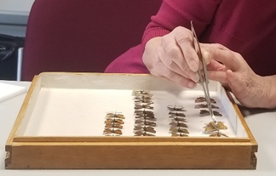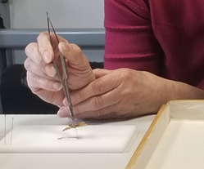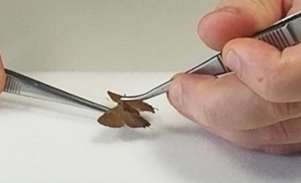
5. Remove the small data labels from underneath the specimen: Get a firm grip on the pin and lift it just clear of the Plastazote foam. Use another pair of forceps to gently move the labels down the pin and onto the Plastazote, one by one, taking care to keep them in the same order that they were on the pin (Image 5). Lay the first label down on the foam, then lay the next label you remove from the pin above it. There may only be one label on the pin, but if there is more than one label, the label which is closest to the specimen should be the label at the top of the column of labels.
6. If there is no label with the scientific name of species under the pin, this can be found at the bottom of a column of specimens (Image 6). Locate the correct species name from your printed sheet of scientific names, cut out this species name label and place this below the other labels.
6
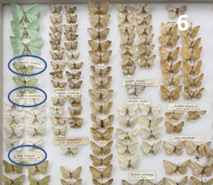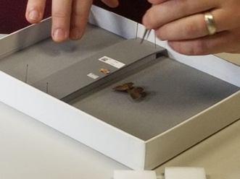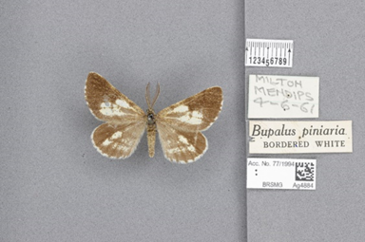
7. Place the specimen on the imaging tray: Put the pinned specimen in the pinhole in the imaging tray. If necessary, move the bar of grey foam so that it is close to the specimen. Secure it with entomology pins at the top and bottom.
8. Arrange the scale bar and specimen labels on the imaging tray: Put the mini scale bar on the bar of grey foam, alongside the specimen. Place the labels on the bar (keeping them in the same order as they were on the Plastazote sheet, i.e., with the one which was closest to the specimen at the top. If necessary, flatten the labels gently before placing them on the grey bar.
9. Cut out the next barcode from the sheet and place it on the grey bar below the pin labels.
10. Put the imaging tray on the stand under the camera and adjust its position.
11. Focus the camera lens. The picture should be sharp with the specimen filling most of the screen.
12. Press the spacebar on the laptop to take the photo using the EOS Utility software. Check to make sure the new image appears on the screen. Images will automatically save into the input folder setup on the laptop for BardecodeFiler.
13. Processing your images: At the end of your digitisation session, open the BardecodeFiler software and press 'Run'. BardecodeFiler will automatically rename the photos with their barcode number (unique identifier) and move the renamed photo to the output folder. The original image will be moved to the processed folder. Images that can’t be processed will be moved to the exceptions folder. Data files are available in the log folder. Save the renamed photos in a new sub-folder in the output folder with today’s date.
14. Check your images: if all the images have a consistent issue that needs to be edited, this can be done in bulk using the XN convert software.
15. Upload your images to your Collections Management System.
16. Transcribe the data from the image to your CMS: scientific name, collector name, collecting date, collecting locality plus other collections management info captured in your normal cataloguing process.
17. Return the specimen and its labels to the drawer: Use a loose pin to make a small hole in the printed barcode, resting it on the spare Plastazote foam. Using forceps, pick up the specimen by its pin and put the original labels back on, in their original order. Lastly, put the barcode on the pin using the hole you made. Try to ensure the barcode is visible when the drawer is viewed from above, in a consistent position.
18. Return the specimen pin to its original hole in the drawer.
19. Make a note of the specimen recorded and any observations (e.g. wing missing, pin very corroded, signs of pest infestation)
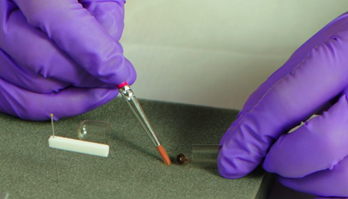
REPAIR
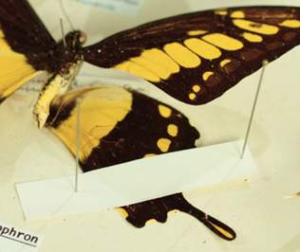
- If there are loose insect parts in the drawer, pick them up gently with a soft brush or soft forceps and place them in a gelatin capsule. Pin it in a clear corner of the drawer (try to use the same corner whenever possible – e.g. bottom right). There is a video of this at https://southwestmuseums.org.uk/resources/gelatin-capsule/
- If insect parts detach and you are sure they came from the specimen you are handling, put them in a gelatin capsule and pin that next to the specimen.
- Breathe on the gelatin capsule first to soften it slightly. Open the capsule and put the parts inside. Close the capsule and push a pin through it, making sure the pin goes through the lid and body of the capsule. Pin it into the drawer close to the correct specimen.
- If the parts are too large to go in a gelatin capsule (e.g. a wing), use one or two small strips of acid-free paper to hold it in place on the floor of the drawer next to the specimen. Pin through the strips carefully, avoiding the insect part. There is a video of this at https://southwestmuseums.org.uk/resources/pinning-paper-strips
If you need further conservation advice – please contact the SWMD Conservation Development Officer at Helena.jaeschke@exeter.gov.uk
There is more information about the pinned insect digitisation process at https://dissco.github.io/PinnedInsect/NHM%20single%20camera%20pinned%20insects.html
SPECIFICATIONS
Hardware:
- Kaiser RS1 copy stand 5511 Serial No 0003064/A
- Canon EOS R6 camera DS126832 Serial No 22039001715
- Canon RF 100mm f2.8 L Macro IS USM Lens
- Canon DR-E6 DC Coupler
- Canon AC-E6N Adapter Kit
- TetherTools TetherPro USB 3.0 to USB-C 15ft (4.6m) Black
- Dell Precision 7560 laptop ST 7Q9C7M3 EX 16825283211 with mains adaptor and backpack bag
- Calumet Cocoon lighting tent 800 x 610 x 580mm
- 2TB Western Digital My Passport hard drive (M.2 Pcie NVMe SSD) PIXAPRO
- MOBI LED Table-Top LED Panel Twin Kit lights
- Hand tools including 2 x large insect forceps, 2 x fine forceps, A4 grey foam sheets, staging tray, pieces of Plastazote white foam, 2 microscales (on paper), 2 insect setting boards (narrow), pack of European size 4 pins
Software:
- Canon EOS Utility
- BardecodeFiler
Camera Settings:
ISO = ; shutter speed = ; aperture =

AUTHORS
Helena Jaeschke and Isla Gladstone, with contributions from Roz Bonnet and Rhian Rowson.

ACKNOWLEDGEMENTS
- Arts and Humanities Research Council
- Bristol Museum and Art Gallery (Bristol City Council)
- Newton Abbot Museum
- Natural History Museum, London
- South West Museum Development

Appendix 2
Herbarium digitisation workflow
This workflow is designed to support the digitisation of herbarium specimens according to best practice making them accessible by researchers. You can read more about this process on the website of DiSSCo UK (The Distributed System of Scientific Collections) https://dissco.github.io/HerbariumSheets/NHMHerbariumSheetDigitisationWorkflow.html#workflow
Health and Safety
Herbarium specimens were often treated with mercuric chloride to prevent attack by pests. Arsenic and other pesticides such as naphthalene and paradichlorobenzene have also been used. Before starting work, check whether the herbarium specimens have been tested for the presence of mercuric salts. If they have tested positive or if they have not been tested at all, you should take adequate precautions to protect everyone working with, or near, the specimens from mercury poisoning by inhalation or ingestion.
- Impermeable gloves, such as nitrile, should be worn by anyone handling the specimens and their folders.
- A mercury vapour proof mask such as http://www.mercurysafety.com/mercury-vapour-proof-mask should be worn by anyone working closely with the specimens.
- All PPE and materials which have come into contact with the specimens (e.g. acid-free tissue) should be bagged up immediately after they are discarded. They can then be disposed of in the normal waste containers.
- The work area should have good ventilation.
- Boxes of herbarium specimens which have not been opened for some time should be opened and left for an hour or more in a fume cupboard or well-ventilated area to allow any accumulated mercury vapour to disperse.
- A record should be kept of the number of hours each person has worked with the herbarium specimens. Any unusual symptoms such as headaches, tiredness, nausea, vomiting and flu-like symptoms such as fever and muscle aches and pains, cough, breathlessness, and chest pain should be reported, and medical advice sought.
- Everyone working in the area with the herbarium specimens should practise good hygiene, washing their hands before and after working in the area and making sure that no food or drink is consumed in the area.
Further information is available at
https://www.gov.uk/government/publications/mercury-properties-incident-management-and-toxicology/mercury-general-information
http://www.mercurysafety.com/health-effects-of-exposure/
https://hazardsincollections.org.uk/mercury-and-its-compounds/sources-and-references
GETTING STARTED
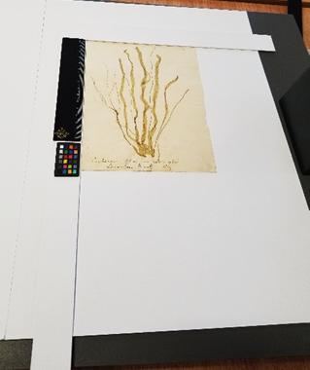
Prepare your digitisation equipment:
- Connect the 4-gang socket extension lead
- Set up the laptop and connect it to a power source
- Set up Kaiser copy stand: insert the column into the baseboard column mount, engage the 2 locating pins then screw in the bolt.
- Remove the camera lens cap
- Connect the camera to a power source with the cable.
- Connect the camera to the laptop.
- Open Canon EOS Utility software: this should launch automatically when the camera is connected to the laptop.
- Check the ISO, shutter-speed, and aperture settings on the EOS Utility window.
- Set up the 2 LED lights and connect them to the power source. Aim them at the area on the copy stand where the object will be positioned. Don’t leave the lights shining on the object longer than necessary.
- Locate the hard drive for image saving at the end of your digitisation session.
Have your tools ready:
- PPE (including well-fitting impermeable gloves, e.g. nitrile)
- For handling specimens:
o Some sheets of acid-free tissue
o fine forceps
o a small soft brush
o scissors
o Blu Tack
o a thin stainless steel spatula
- For labelling specimens:
o The sheet of barcodes encoding your specimen numbers, printed on archival quality labels, using waterproof, fade proof ink. If labels cannot be attached to the herbarium sheet, the barcodes can be printed on acid-free paper using waterproof, fade proof ink.
o Notebook and pencil
- For photographing specimens:
o The imaging frame (2 A3 pieces of acid-free card joined together to form the backing, with an L-shaped piece of acid-free card with a ruled scale and a nano colour scale attached). This acts as a placeholder to make sure that the herbarium sheets are placed in the correct area under the camera lens.
PROCEDURE
1. Carry the folder of herbarium specimens to your digitisation location, taking care to keep it horizontal and to minimise vibration in case any specimen parts are loose. Lay it out on a clean area protected with acid-free tissue.
2. When opening the folder, take care to lift each separate page out and place it specimen side up on the acid-free tissue. Never turn the pages of the herbarium over. Maintain the order of the pages, lifting each one out in turn and laying it gently on the one before. You can place a sheet of acid-free tissue in between the pages if the specimens appear very fragile or loose.
3. Choose the next specimen to photograph.
4. Place the imaging frame on the copy stand so that the L-shaped piece is in the edge of the camera view.
5. Place the herbarium sheet on the imaging frame so that the top left hand corner of the sheet is in the top left hand corner of the L-shaped card.
6. If the herbarium sheet is uneven or curling, use tiny (pinhead sized) blobs of Blu Tack under the sheet to secure it to the imaging frame card beneath. Place the Blu Tack on the imaging card and press it firmly in place. Then very lightly press the herbarium sheet onto it. Press the barcode label gently on the sheet in the top left corner, a finger’s-width in from each side, and at least this distance from any of the specimens. If this is not possible, the barcode is placed either along the top or the bottom of the sheet. Barcodes are aligned horizontally. In unusual cases (for example, where the herbarium specimens have been arranged to form a work of art) if it is not possible to attach the barcode as a label, it can be printed on acid-free paper and laid on the sheet while the photograph is taken, then removed before the sheet is returned to the folder.
7. Focus the camera lens. The picture should be sharp with the specimen filling most of the screen and the original label and barcode clearly visible.
8. Press the spacebar on the laptop to take the photo using the EOS Utility software. Check to make sure the new image appears on the screen. Images will automatically save into the input folder setup on the laptop for BardecodeFiler.
9. Use BarcodeFiler to rename the photo with the barcode number and move it to the chosen folder. Once set up the program will do this automatically[IG11] .
10. If you had to use Blu Tack to hold the herbarium sheet flat, slide the spatula underneath to gently detach it from the Blu Tack. Take great care to make sure no Blu Tack is left attached to the herbarium sheet.
11. If the barcode was printed on plain paper and is not attached to the herbarium sheet, gently lift it off using forceps. Keep it safe to make sure it is not mistakenly re-used with another specimen. It can be attached to a spare sheet of acid-free paper with the list of specimen numbers, kept at the front of the folder.
12. Return the herbarium sheet to its original place in the folder.
13. Make a note of the specimen recorded and any observations (e.g. parts loose or missing, evidence of pest attack).
14. Processing your images: At the end of your digitisation session, open the BardecodeFiler software and press 'Run'. BardecodeFiler will automatically rename the photos with their barcode number (unique identifier) and move the renamed photo to the output folder. The original image will be moved to the processed folder. Images that can’t be processed will be moved to the exceptions folder. Data files are available in the log folder. Save the renamed photos in a new sub-folder in the output folder with today’s date.
15. Check your images: if all the images have a consistent issue that needs to be edited, this can be done in bulk using the XN convert software.
16. Upload your images to your Collections Management System
17. Transcribe the data from the image to your CMS : [check: scientific name, collector name, collecting date, collecting locality plus other collections management info captured in your normal cataloguing process]
If you need further conservation advice – please contact the SWMD Conservation Development Officer at Helena.jaeschke@exeter.gov.uk

SPECIFICATIONS
Hardware:
- Kaiser RS1 copy stand 5511 Serial No 0003064/A
- Canon EOS R6 camera DS126832 Serial No 22039001715
- Canon RF 100mm f2.8 L Macro IS USM Lens
- Canon DR-E6 DC Coupler
- Canon AC-E6N Adapter Kit
- TetherTools TetherPro USB 3.0 to USB-C 15ft (4.6m) Black
- Dell Precision 7560 laptop ST 7Q9C7M3 EX 16825283211 with mains adaptor and backpack bag
- Calumet Cocoon lighting tent 800 x 610 x 580mm
- 2TB Western Digital My Passport hard drive (M.2 Pcie NVMe SSD) PIXAPRO
- MOBI LED Table-Top LED Panel Twin Kit lights

- Hand tools including 2 x large insect forceps, 2 x fine forceps, A4 grey foam sheets, staging tray, pieces of Plastazote white foam, 2 microscales (on paper), 2 insect setting boards (narrow), pack of European size 4 pins
Software:
- Canon EOS Utility
- BardecodeFiler
Camera Settings:
ISO = ; shutter speed = ; aperture =

AUTHORS
Helena Jaeschke, with contributions from Roz Bonnet, Rhian Rowson, Isla Gladstone.

ACKNOWLEDGEMENTS
- Arts and Humanities Research Council
- Bristol Museum and Art Gallery (Bristol City Council)
- South West Heritage Trust
- Natural History Museum, London
- South West Museum Development

Acknowledgements
This pilot was generously supported by:
- Arts and Humanities Research Council
- Arts Council England
- Bristol City Council
- Natural History Museum, London

p27, Smith, V.S., Hardy, H., Wainwright, T., Livermore, L., Fraser, N., Horak, J., Aspinall, J. and Howe, M., (2022) Harnessing the power of natural science collections: A blueprint for the UK published by DiSSCo UK, pp1-28. Natural History Museum. doi: https://doi.org/10.5281/zenodo.6472239
Kaiser, K., Heumann, I., Nadim, T., Keysar. H., Petersen, M., Korun, M. & Berger, F., (2023) Promises of mass digitisation and the colonial realities of natural history collections, published by Journal of Natural Science Collections: Journal Article | Natural Sciences Collections Association (natsca.org)

